**Chapter 3**

**System Analysis**

**3.1 Study of Current System and Requirement of this System**

**3.1.1 Study of Current System**

* This application does not allow users to recover their passwords.
* It is not going to allow users to ignore or remove their crime reports.
* It would also not allow changing in their profile.
* It is not fully secured as anyone can visit anyone’s profile.

**3.1.1 Study of Current System Screenshots**

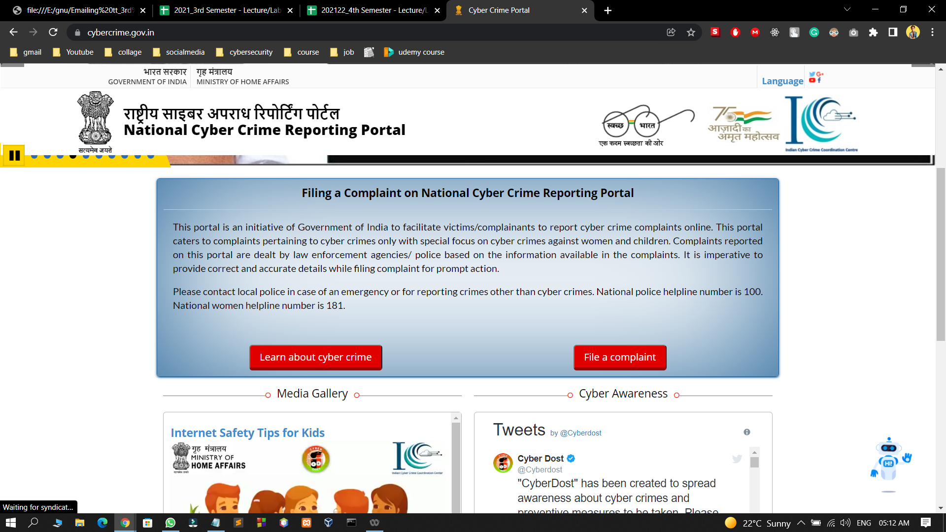

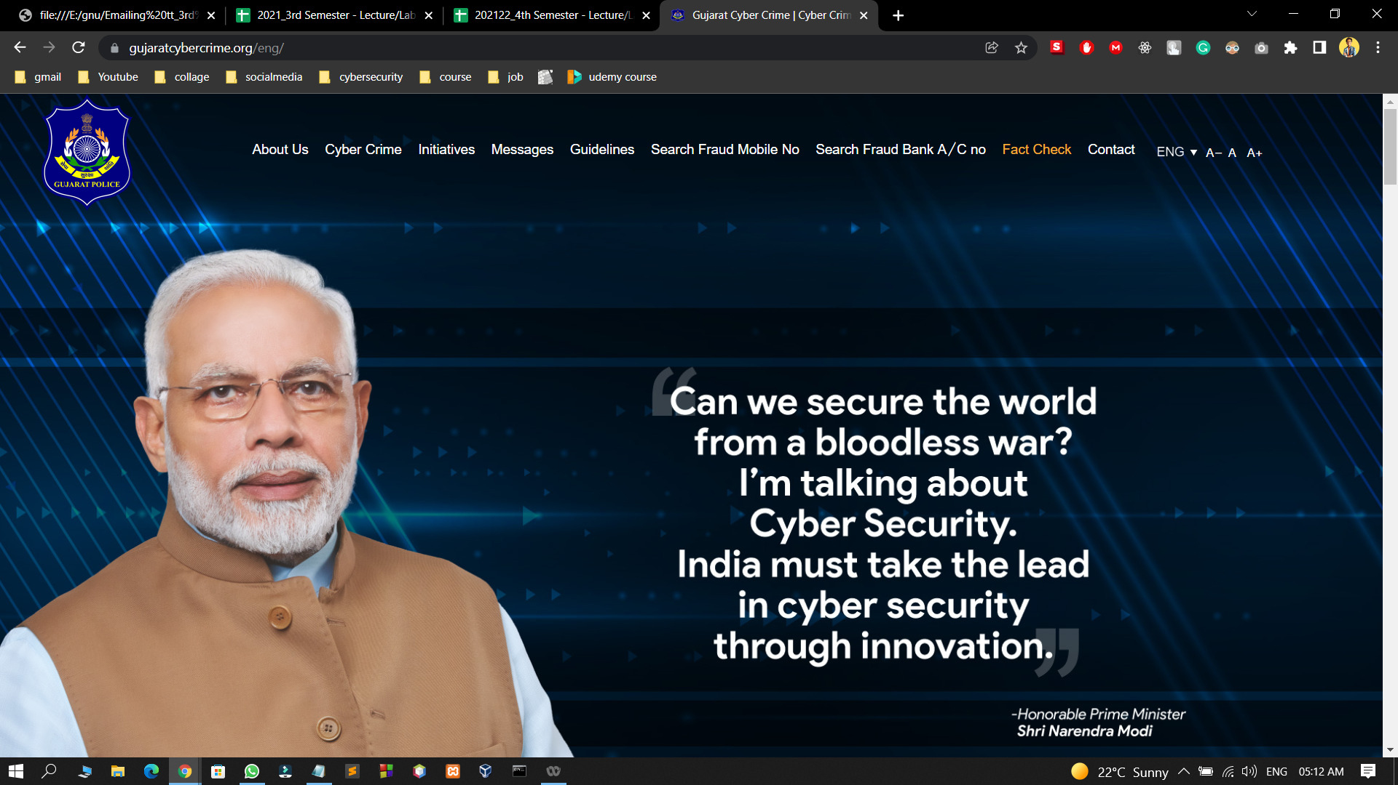

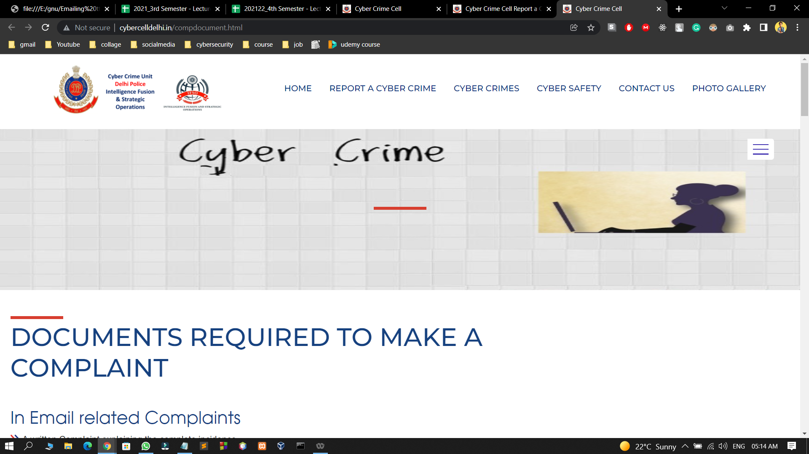

**3.2 Data Dictionary**

**3.2.1 Casefile Data Table**

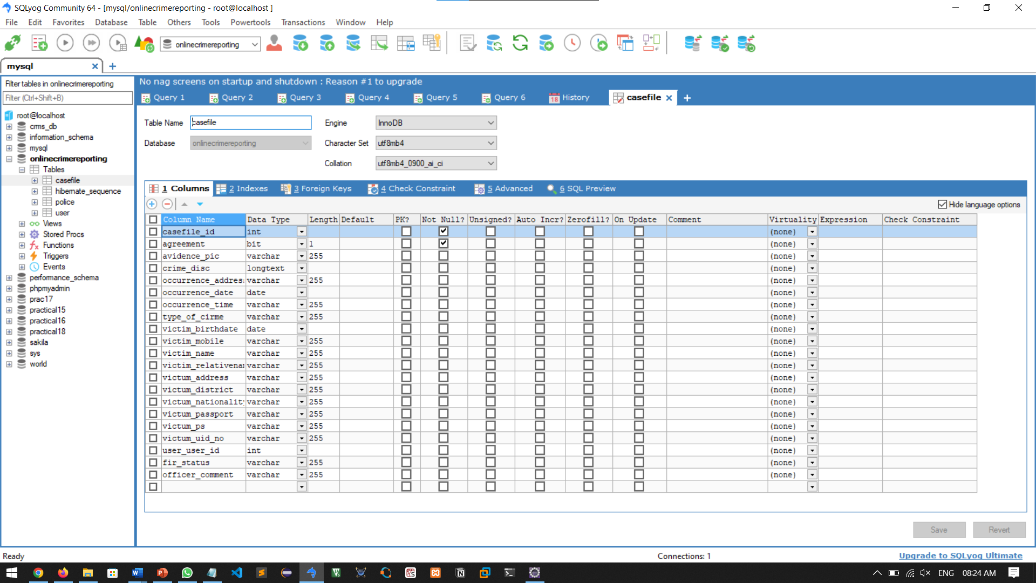

**3.2.2 User Data Table**

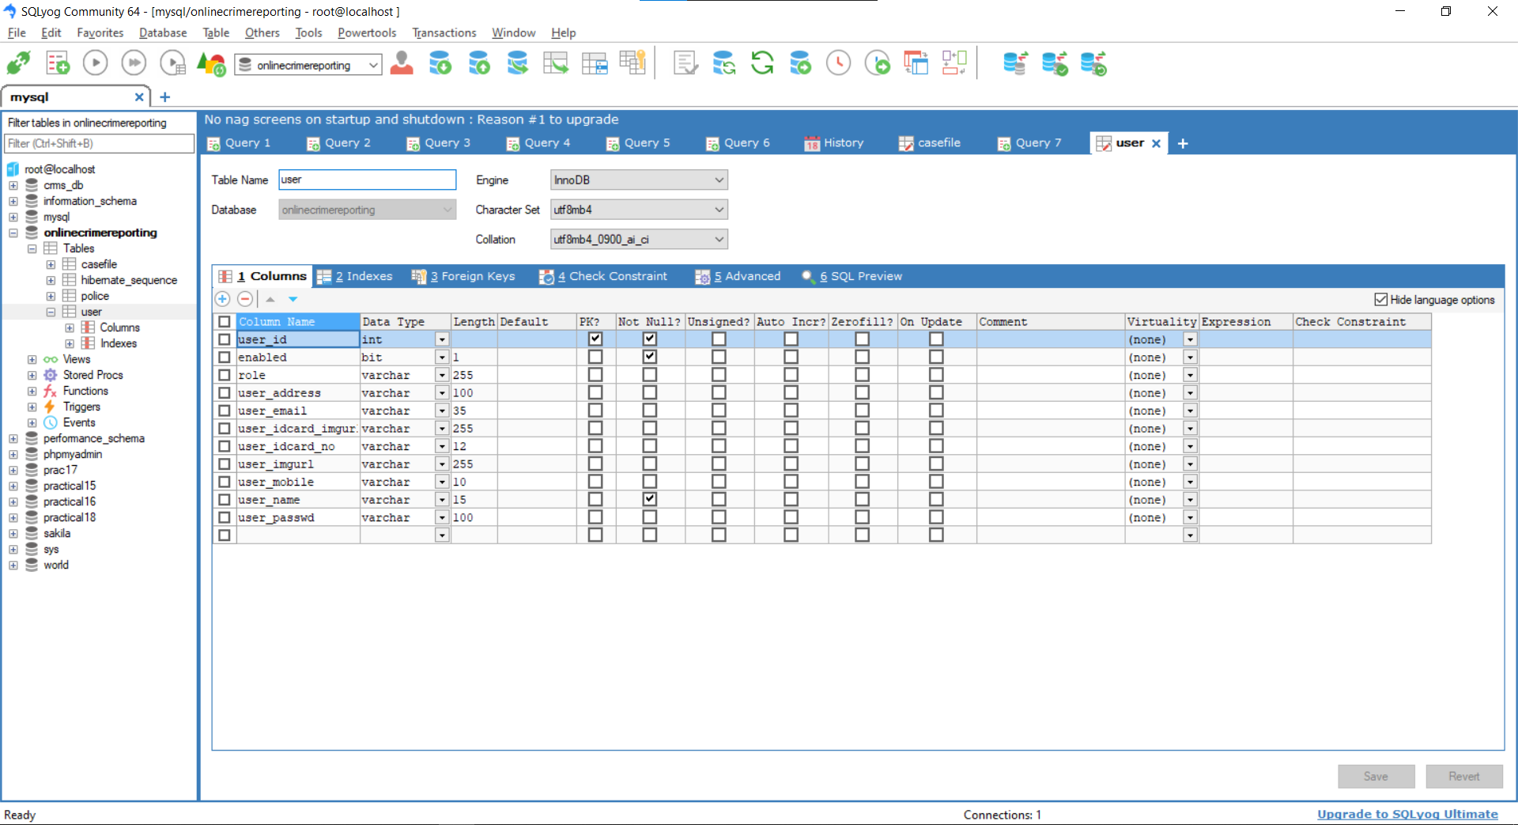

**3.2.3 Police Data Table**

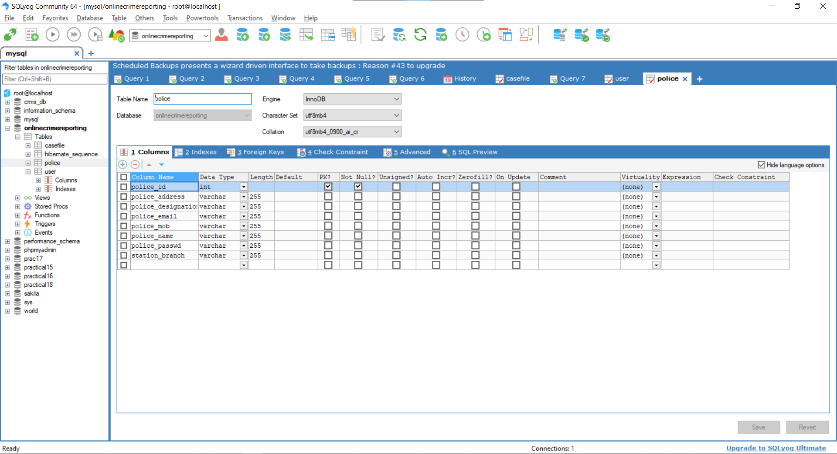

**3.3 Modules and Their Description of System**

TOTAL MODULE

LOGINPAGE………………….………………………………………………………….….1

MAIN PAGE………………….……………………………………………………………...2

ADMIN PAGE………………….……………………………………………………………3

USER PAGE.……………………………………………………………...…………………4

OFFICER PAGE………….……………………………………………………….....………5

1. Login Page

* It is a basic login page where the user is allowed to access the webpage only if it's valid.
* And also we are filtering the admin and local user for more features availability(Admin Part)

1. Main Page

* The main page is divided into 3 main parts.

1. Login User Details
2. Question Writing Area/Text area
3. Previous Question List
4. Admin Page

* All control of the webpage is available here from answering the question blocking user. And selecting teachers for each subject and semester.
  1. Add/Update/Display/Delete Police Officer (Police Station)
  2. Add/Update/Display/Delete Citizen (User)
  3. Update/Display/Delete Complaint
  4. View/Delete Complaints Status
  5. View/Delete Emergency Complaint
  6. View Query
  7. View Feedback

1. User Page

* The user can register himself and register fir and can update his profile and can track his fir status.
  1. Registration and login page
  2. Notify to your near police station
  3. Awareness about cyber hygiene
  4. Complain anonymously
  5. Add/update/delate complains
  6. Uploading system for files like photos, pdf, etc.
  7. Proper guidance to problem solutions
  8. Tracking to your complain